1) remove the 8 campagins remove 40,000, 56,000, 80,000, and 100,000

After removing, 7340 campaigns left.

2) For the tests need the histogram of the variables

3) change the scale type back to 0-7

Correlation coefficient graph

|  |  |  |  |  |  |
| --- | --- | --- | --- | --- | --- |
|  |  | Mean | Std.Dev | Skew | Kurt |
| [1] | DV: Donation Amount | 11020 | 44312 | 18.76 | 515 |
| [2] | Campaign Goal | 43904 | 127925 | 8.15 | 93.57 |
| [3] | Tax Deductibility | 0.95 | 0.21 | -4.29 | 16.39 |
| [4] | Campaign Duration | 112 | 110 | 1.36 | 0.53 |
| [5] | Campaign Video | 0.346 | 0.476 | 0.646 | -1.58 |
| [6] | Number of images | 3.01 | 1.56 | -0.004 | -1.52 |
| [7] | Words of campaign | 138 | 67 | 0.024 | -1.04 |
| [8] | Creator Type | 0.65 | 0.94 | 2.78 | 11.32 |
| [9] | Scale Type | 5.64 | 1.17 | -1.69 | -4.04 |
| [10] | Sector Type | 1.02 | 1.25 | 1.23 | 1.53 |
| [11] | Start Year category | 3.23 | 1.37 | -0.76 | -0.098 |
| [12] | Campaign frequency | 12.98 | 26.98 | 3.18 | 9.80 |
| [13] | Future tense % | 0.01 | 0.02 | 1.88 | 2.46 |
| [14] | Avg custom amount | 146.6 | 756 | 18.74 | 500 |

Statistics

Statistics

Table1 correlation Matrix and descriptive statistics

|  |  |  |  |  |  |  |  |  |  |  |  |  |  |  |  |  |  |  |
| --- | --- | --- | --- | --- | --- | --- | --- | --- | --- | --- | --- | --- | --- | --- | --- | --- | --- | --- |
|  |  | Mean | Std.Dev | Min | Max | [1] | [2] | [3] | [4] | [5] | [6] | [7] | [8] | [9] | [10] | [11] | [12] | [13] |
| [1] | DV: Donation Amount | 11020 | 44312 | 10 | 1602948 | 1 |  |  |  |  |  |  |  |  |  |  |  |  |
| [2] | Campaign Goal | 43904 | 127925 | 100 | 2000000 | 0.57 | 1 |  |  |  |  |  |  |  |  |  |  |  |
| [3] | Tax Deductibility | 0.95 | 0.21 | 0 | 1 | 0.02 | -0.05 | 1 |  |  |  |  |  |  |  |  |  |  |
| [4] | Campaign Duration | 112 | 110 | 2 | 365 | 0.25 | 0.41 | -0.013 | 1 |  |  |  |  |  |  |  |  |  |
| [5] | Campaign Video | 0.346 | 0.476 | 0 | 1 | 0.051 | 0.041 | 0.0029 | 0.032 | 1 |  |  |  |  |  |  |  |  |
| [6] | Number of images | 3.01 | 1.56 | 0 | 5 | 0.069 | 0.069 | -0.025 | 0.07 | 0.039 | 1 |  |  |  |  |  |  |  |
| [7] | Words of campaign | 138 | 67 | 1 | 294 | 0.23 | 0.25 | -0.033 | 0.056 | 0.009 | 0.12 | 1 |  |  |  |  |  |  |
| [8] | Creator Type | 0.65 | 0.94 | 0 | 7 | -0.17 | -0.47 | 0.1 | -0.25 | 0.081 | -0.023 | -0.24 | 1 |  |  |  |  |  |
| [9] | Scale Type | 5.64 | 1.17 | 0 | 7 | 0.021 | -0.053 | 0.28 | 0.0066 | -0.003 | -0.11 | -0.044 | 0.15 | 1 |  |  |  |  |
| [10] | Sector Type | 1.02 | 1.25 | 0 | 7 | 0.021 | 0.1 | -0.04 | 0.042 | 0.005 | -0.016 | 0.11 | -0.13 | -0.068 | 1 |  |  |  |
| [11] | Start Year | 3.23 | 1.37 | 0 | 5 | -0.058 | -0.16 | -0.061 | -0.17 | -0.029 | -0.12 | -0.043 | 0.16 | 0.012 | -0.036 | 1 |  |  |
| [12] | Campaign frequency | 12.98 | 26.98 | 1 | 134 | -0.2 | -0.36 | 0.11 | -0.18 | -0.088 | -0.14 | -0.15 | 0.29 | 0.2 | -0.12 | 0.31 | 1 |  |
| [13] | Future tense % | 0.01 | 0.02 | 0.0 | 0.129 | 0.13 | 0.28 | -0.094 | 0.097 | -0.006 | 0.081 | 0.15 | -0.52 | -0.097 | 0.0008 | -0.077 | -0.18 | 1 |
| [14] | Avg custom amount | 146.6 | 756 | 0.0 | 27500 | 0.25 | 0.55 | -0.12 | 0.24 | -0.055 | 0.038 | 0.25 | -0.86 | -0.14 | 0.12 | -0.12 | -0.31 | 0.53 |

VIF Test

The new regression result.

Without log transformation

Actual_Donation_Amount 1.2069810104277907

Campaign_Goal 1.2731889485381112

NPO_Ipc_Status_For_Tax_Deductibility 1.2932281175938398

Campaign_Duration 1.1275970472247532

Campaign_Video 1.0283229581800035

Campaign_Image_Number 1.0738031761560938

Number_of_words_describing_campaign 1.0692821721720043

Creator_Type 1.2310732197235983

Scale_type 1.3367183466211825

Sector_type 1.0347177336477438

Campaign_Start_Year_category 1.1170697801630953

Campaign_frequency 1.2204803850363526

Future_tense_percentage 1.164962392150795

Avg_custom_amount 1.0419935221668806

Base model

Last version:

Residual standard error: 1.5875834139825278

Predicted R2: 0.3395480186514015

Updated version:

Residual standard error: 1.5878672351853094

Predicted R2: 0.3397208163273283

Base model + Future_tense_percentage + Log_avg_custom_amount

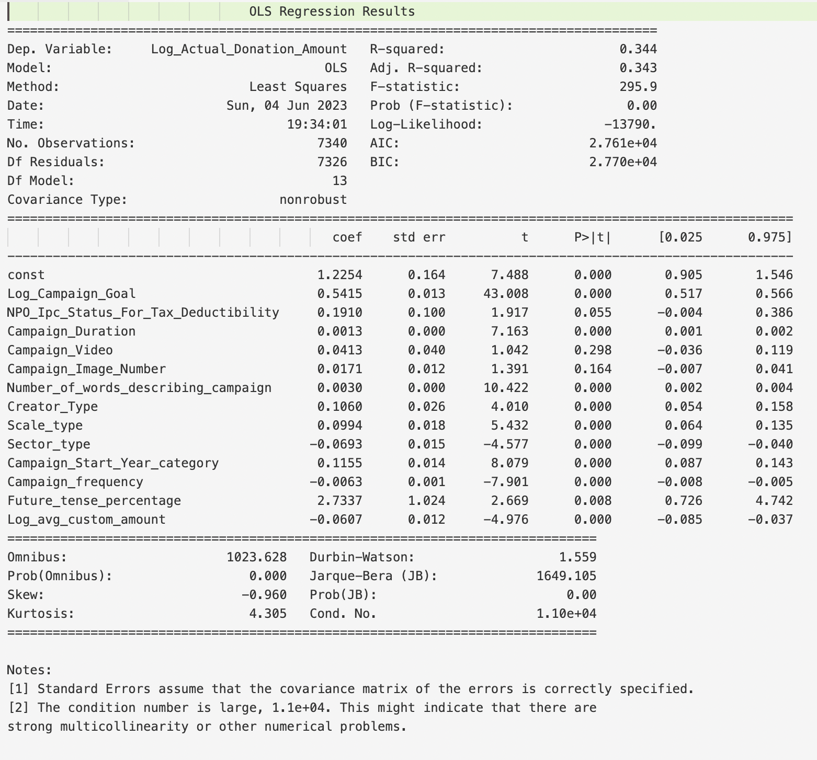

Last version:

Residual standard error: 1.5849140549661294

Predicted R2: 0.3415543555034526

Updated version:

Residual standard error: 1.5852994462791985

Predicted R2: 0.3416402561605735

Model 3 = Model 2 + Future_tense_percentage_X_Log_avg_custom_amount

Last version:

Residual standard error: 1.58213757230085

Predicted R2: 0.34366431775478046

Update version:

Residual standard error: 1.5824571200765034

Predicted R2: 0.3438009724576291

Robustness test 1

Last version:

Residual standard error: 1.2615295245458051

Predicted R2: 0.272537461813088

Updated version:

Residual standard error: 1.2618518825091873

Predicted R2: 0.27263395026733495

Robustness test 2

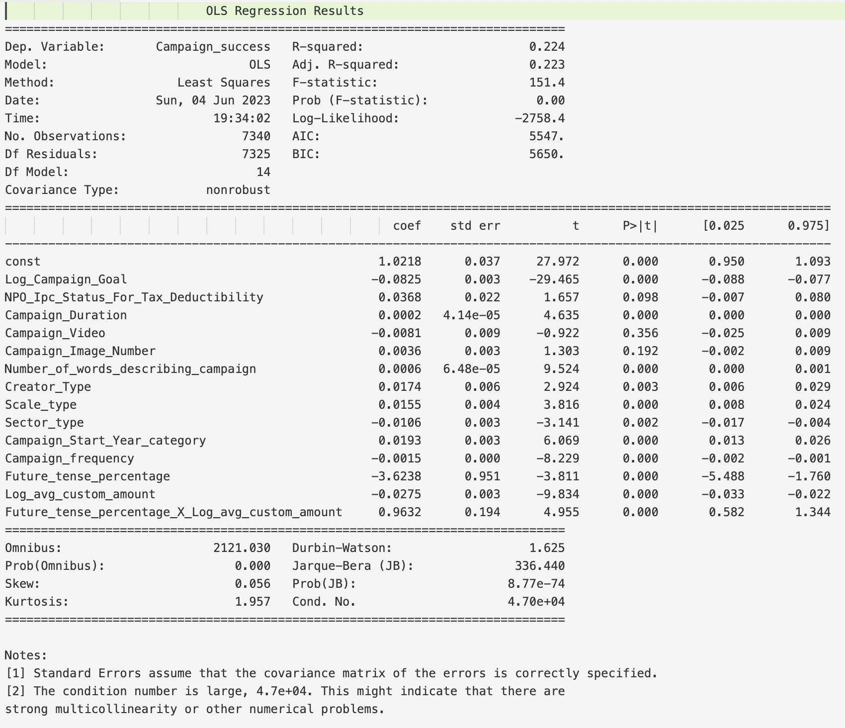

Last version:

Residual standard error: 0.3526142393655064

Predicted R2: 0.221949339097257

New version:

Residual standard error: 0.3527073943804329

Predicted R2: 0.2212827844686216

The result below are all based on Model 3

4) do 3 seperate residual plot of each IV, and the interaction varible

5) for current residual plot, do pixel and make nicer

6) for the qq plot, extend axis, and do in the same pixel form

I am not sure what is the meaning of “do in the same pixel form”. You can have a look first, can make further change if need.

7) use minitab again to flag for large residuals in Y and in indepedent variables

I am not sure the meaning of this part, I filter the campaingns whose absolute residual more than 2

Here, there are 368 campaigns whose absolute residual more than 2

